**President’s Message, April 2021**

Passover provides many opportunities for reflection. One commentary suggests that the ceremony itself—the Seder—provides deep lessons, one of which is that true freedom is found in service. This idea of service is essential to the Jewish world. It creates the individual and collective meaning of life. Service is the foundation on which Hadassah was established and has never wavered.

**Hadassah Medical Organization (HMO) Update**: This month it is truly fitting to highlight the individual service of one woman, Yael Cohen, a nurse in the Pediatric Unit at Hadassah Hospital Ein Kerem. Cohen was caring for two Arab children whose mother suffered extensive injuries in a car accident. The six-year-old was convinced to eat, but the baby, who had only been breastfed, had no interest in taking a bottle. “It broke me to see the baby suffering, hungry and without her mother at her side,” Cohen stated. This was her motivation to ask the family’s permission to breastfeed the child. Cohen adds, “I don't ask who the family is. I embrace them with all the tools and compassion possible.” Cohen’s multicultural approach to all patients is an unwavering value at HMO. Medicine is recognized as a bridge to peace. Her individual call to service is a powerful and heartwarming story [and was beautifully articulated in Arutz Sheva, Israel National News.com, now on our website.](https://www.hadassah.org/story/hadassah-nurse-breastfeeds-baby-for-arab-mom-injured-in-car-crash)

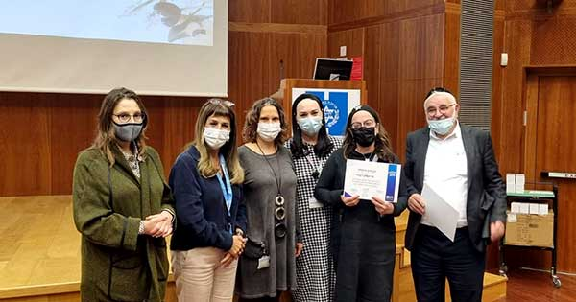

Honors for other acts of service were recently presented at HMO to *Ezer Mizion* volunteers. These individuals’ efforts illustrate the acts of selflessness needed to weather the international crisis created by the COVID-19 pandemic. The volunteers of *Ezer Mizion*, a group long partnered with HMO, worked side by side with medical providers at Hadassah Hospital Ein Kerem’s COVID-19 Outbreak Unit. The volunteers’ mission was to ease the pain and isolation of patients who were suffering from the long-term effects of COVID-19. The volunteers, all recovered COVID-19 patients who had high antibody levels, feed patients, help with dressing and bathing, offer sustenance and communicate with patients’ families. Hadassah, the first hospital in the world to welcome such volunteers, modeled this initiative for other hospitals. [On March 10, 2021, there was a ceremony of heartfelt thanks to the *Ezer Mizion volunteers.*](https://www.hadassah.org/story/hadassah-honors-covid-19-outbreak-unit-volunteers)

**New Hadassah Radio Program**: Hadassah believes that the work we do and the acts of service we provide must be undergirded with current information. To that end a new radio series, [Hadassah Presents: Women of Vision](https://www.hadassah.org/podcast/women-of-vision), has been launched. Hadassah CEO Janice Weinman is conducting interviews highlighting the visionary leadership and innovative approaches of women as they surmount the challenges in their respective fields. The show airs on TalkLine with Zev Brenner. The first show is already accessible on the Hadassah national website. The interview features Dr. Mehnaz M. Afridi, the only Muslim teacher of the Holocaust in the US. She is an associate professor of Religious Studies at Manhattan College and director of its Holocaust, Genocide, and Interfaith Education Center. This episode is titled “Bridging Divides Through Holocaust Education.” Dr. Afridi is a brilliant, thoughtful and courageous speaker. You must not miss listening to her creative ideas about freedom and peace.

**Philanthropy**: Every action has an impact, and every dollar brings us closer to fulfilling our promises to the people we serve here in the US and in Israel. Your financial support of Hadassah is an ongoing act of loving service and deeply appreciated. It is important to know and to be able to explain the many ways you may be able to participate philanthropically. One way is to donate securities. Because gifts of securities are tax deductible at their full market value on the day of transfer, you can potentially save income tax and capital gains tax on the appreciation. Hadassah is lucky to have skilled professionals to educate and guide you through this process. Please look at [the stock donation form](https://assets.website-files.com/5f207c2cb5e70085bd1bd76e/60088a1c484b42926af11c1f_Hadassah%20Stock%20Transfer%20Form-%20HWZOA__January%202021.pdfand%20) and contact Tanya Stolstein at 212-303-8067 or [tstolstein@hadassah.org](mailto:tstolstein@hadassah.org).

Chag Pesach kasher ve’sameach

May Hadassah offer us connection through our shared acts of giving service.