President’s Message, December 2021

This month we celebrate Hanukkah, the festival of lights commemorating the recovery of Jerusalem and the rededication of the [Second Temple.](https://www.britannica.com/topic/Temple-of-Jerusalem) In Hebrew the word *hanukkah* actually means *dedication*. It is only fitting that this month’s message should be dedicated to the nearly 300,000 Hadassah volunteers who support the organization philanthropically and with unending gifts of time and expertise. Volunteers have always been at the core of Hadassah’s accomplishments. We continue to salute the women and men whose personal dedication supports our mission of *tikkun olam*, to repair the world, where it’s needed most, in the US, Israel and around the world. Hadassah continues to fight for Holocaust and anti-hate education funding in schools, to conduct groundbreaking medical research and to set youth at risk on a path to success.

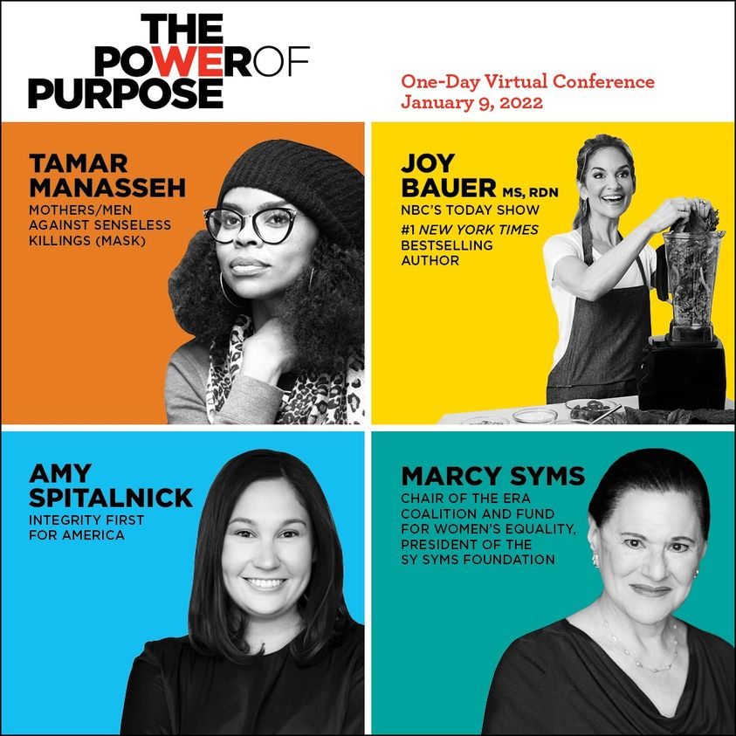**Leadership Update – Just Announced:** We are more than excited to announce that Jenna Bush Hager, co-host of NBC’s *TODAY* Show and best-selling author, will be our keynote speaker at [Hadassah’s first-ever virtual conference](https://www.hadassah.org/powerofpurpose%23speakers). Focused on empowering women, “The Power of Purpose” takes place on Sunday, January 9, 2022, starting at 11 am EST. In addition to Jenna Bush Hager, Hadassah is bringing together a phenomenal and inspiring group of women who will share how they have found their life’s purpose. The four panels will focus on advocacy, women’s health, Israel and women’s empowerment. One of the speakers, Tiffany Dufu, the founder of The Cru, a peer-coaching platform, states, “My life’s work is advancing women and girls;that’s pretty much why I am on the planet.” Dufu has also served as president of The White House Project and authored the bestselling book *Drop the Ball: Achieving More by Doing Less*. Other women speaking include Amy Spitalnick, executive director of Integrity First for America; Tamar Manasseh, founder of Mothers/Men Against Senseless Killings (MASK); and Joy Bauer, a nutrition and healthy lifestyle expert for NBC’s *TODAY* show. **This conference is about and for women.** Dedicating time to women’s empowerment is a gift we can give ourselves. [**Register today**](http://www.hadassah.org/powerof%20purpose) **and invite your friends!**

**Hadassah On Call Podcast Update**: Headaches are ubiquitous, and the causes and etiology of headaches are often unknown. Hence, the focus of the latest installment of Hadassah On Call: New Frontiers in Medicine is [*It's All in Your Head: Why Headaches Matter*.](https://www.hadassah.org/episode/its-all-in-your-head-why-headaches-matter) The guest is Prof. Maxim Bauer, a senior neurologist, who has just helped open a new interdisciplinary headache clinic at Hadassah Hospital Ein Kerem in Jerusalem. The clinic’s staff includes pain doctors, orthopedists, anesthesiologists, neurologists and other medical professionals. Interestingly, they are seeing a large number of patients suffering from the aftereffects of COVID-19. Dr. Bauer shares recent breakthroughs, prevention tips and information about migraine headaches. In the podcast Dr. Bauer explains, “A migraine is the sixth most prevalent disorder in the world and the second leading cause of disability after back pain.” He also states that there are around 200 different types of headaches, including the incredibly painful cluster headaches and thunderclap headaches. The information shared in the podcast can offer the listener much needed direction for the resolution of headache pain.

**TOGETHER IN ISRAEL: Our Pride. Our Purpose.** **Hadassah’s 100th Convention** will take place in Jerusalem, November 14-17, 2022. There’s nothing like a Hadassah convention in Israel. This is our first in a decade and our best lineup yet! Share the sense of pride and purpose in our work as we visit our projects and meet the people whose lives we’ve touched. Connect with fellow members, enjoy Israeli history, art and culture through a variety of track choices and leave invigorated and inspired to continue your support for Hadassah and for Israel. **Watch your emails for the special** **Early-Bird discount and save $250 per person when you register by February 28**. Questions? Contact Ayelet Tours at [hd@ayelet.com](mailto:hd@ayelet.com), 1-800-237-1517.

Happy Hanukkah! May the gift of this holiday be a rededication to that which brings you purpose and joy.