**President’s Message, June 2021**

In the Book of Ecclesiastes there is saying we all recognize: “To everything there is a season.” As we move into June, the season shifts to summer, a time for vacations, reconnecting with family and perhaps spending some lazy days on the beach reading a good book. It’s a great time to read about Hadassah’s accomplishments and projects for the future.

**HMO Delegation Travels to Argentina: Early this May the** Hadassah Medical Organization sent a delegation to Argentina to provide critical knowledge and experience to frontline medical professionals in Argentina in the global fight against the COVID-19 pandemic. Robert Dorfman, president of Hadassah International, stated, “The Israeli delegation's visit also provides an opportunity to broaden the lines of communication and cooperation that go beyond the challenges of COVID-19 and may result in a wide range of areas in which lifesaving procedures and research can be shared for the betterment of humankind.” Leading the delegation was Prof. Yoram Weiss, director of Hadassah Hospital Ein Kerem, and Hadassah International Executive Director Jorge Diener. Argentinian Ambassador to Israel Sergio Urribarri accompanied the team along with expertly skilled COVID-19 medical personnel from HMO. Rhoda Smolow, national president of Hadassah, said,“Hadassah’s medical care is not constrained by geographic boundaries. With COVID-19 spiraling out of control in Argentina and the country’s healthcare system in crisis, Hadassah has a moral obligation to step in. We are extremely proud of the HMO delegation, an all-star team of leading doctors, specialists in COVID-19 and a nurse from the COVID-19 ICU​, who have volunteered to travel across the world. They will provide critical expertise to Argentina as it struggles to manage the onslaught of COVID-19 cases and stave off the worst effects of this terrifying disease.”

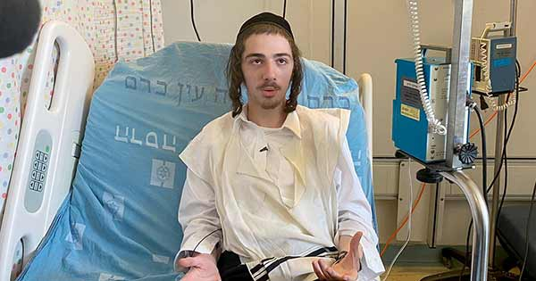

**Meron Survivors Treated at Hadassah**: On April 30, 2021, the holiday of *Lag BaOmer,* a deadly crowd crush occurred in Meron at the tomb of Rabbi Shimon bar Yochai. Visiting the tomb is an annual event; this year’s crowd was estimated at 100,000, much lower than usual due to the pandemic. When several men slipped on a steep and narrow pathway, they were trampled by others behind them. Forty-five died as a result. Five of the wounded were transported to Hadassah Ein Kerem for medical treatment as well as support for PTSD. Among the patients was a 16-year-old boy from Brooklyn, NY, Israel Meir Friedman, who almost lost his life. Crushed under the weight of bodies, he was rescued by Israel Defense Force (IDF) soldiers. Recalls Israel, “There were screams and mostly shouts of *Shema Yisrael*. I said the *Shema*, expecting to die.” [This brave young man then opted to let the soldiers go help others.](https://www.hadassah.org/story/i-said-the-shema-expecting-to-die-says-teenage-hadassah-patient%20) Once he arrived home, his parents noted that he needed more help, and he was taken to Hadassah Ein Kerem, where he was treated for internal injuries. His parents expressed their gratitude for the miraculous help offered by the IDF and Hadassah. The moving story was captured on Israeli television from the patient’s bed in Hadassah’s Charlotte Bloomberg Mother and Child Center.

## **Philanthropy and Hadassah Israel Travel Update:** This year Hadassah celebrates 25 years of Keepers of the Gate! This summer is a wonderful time to be sure to honor those in your units who are already Keepers and encourage others to join this select society of donors. While planning the program, be sure to include this video of [the Six-13 a cappella group singing Hadassah’s Keepers of the Gate song](https://www.hadassah.org/video/six13-keepers-of-the-gate). You will get a guaranteed 5-minute smile. Remind your members that Keepers of the Gate commit to an annual donation of at least $1,000, payable in increments over the course of the year. [These annual-giving commitments](https://www.hadassah.org/donate/learn-more/annual-giving) allow Hadassah to budget effectively. The money plays a critical role in supporting lifesaving medical breakthroughs and cutting-edge care, helping to sustain a strong Israel, empowering women to effect change and providing at-risk youth in Israel with a bright future. It would also be a terrific time to announce that Israel is back open for tourism. On Nov. 7–14, 2021, plan to join your sisters on the [Hadassah Keepers of the Gate Tour of Israel.](https://secure.ayelet.com/HDKeepers2021.aspx) Look for the tour information as soon as possible—if you book by July 15, you will be offered a $600 dollar discount.

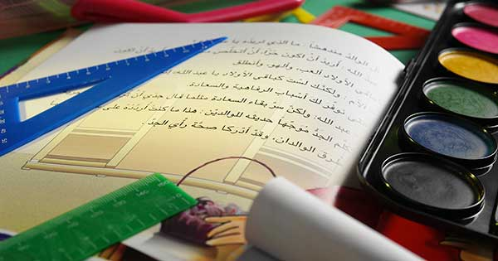**Advocacy and Education Update**: This information is a must read and must act this summer. Hadassah is organizing a congressional effort including lawmakers from both sides of the aisle to protect children from being taught hatred and antisemitism. In the face of rising antisemitism, hatred and extremism worldwide, this coalition will urge UN Secretary-General António Guterres to stop schools run by United Nations Relief and Works Agency for Palestine Refugees in the Near East (UNRWA) from teaching Palestinian children lessons steeped in hatred, antisemitism and violence. Though the Palestinian Authority has promised to change the curriculum, the practice continues. [Take the time to educate yourself about this issue](https://www.hadassah.org/story/hadassah-organizes-a-bipartisan-effort-to-protect-children-from-classrooms-teaching-hatred-antisemitism) by visiting the National Action Center and urge your senators and representatives to sign a bipartisan letter.

Enjoy the season and bask in the warmth of a good read!