**President’s Message, May 2021**

The colors and beauty of spring are inspirational. Now that many of us have been immunized against COVID-19, spring is a time that provides more possibilities to gather with family and friends. It’s a perfect time to reflect on the inspiration we derive from Hadassah. This inspiration comes from the connections we make and the work that is accomplished.

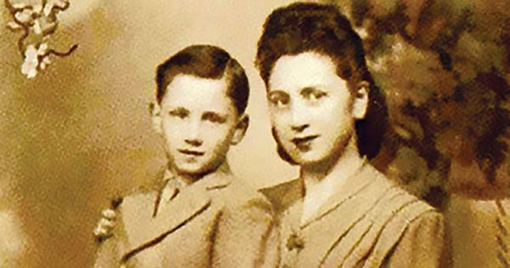**HMO Update**: What can be more inspirational than reflecting on the resilience of humanity. This month you can [read the story of Dr. Saul Perlberg](https://www.hadassah.org/story/from-hidden-child-during-the-holocaust-to-hadassah-surgeon), who at age 80 is still a practicing urologist/surgeon at Hadassah Hospital Mount Scopus, where he has provided medical care for many decades. Born in Belgium in 1941, Dr. Perlberg is also a survivor of the Nazi scourge, a history he chose not to reveal until 16 years ago. During the war he was hidden by a gentile neighbor. At war’s end, living in an orphanage, he was reunited with his mother, and both made aliyah to Israel in 1949. His father was murdered in Auschwitz. Dr. Perlberg tells the story of finding love, meaning and the safety of living among his coreligionists in his new home. He praises the bravery of his benefactor, who saved his life. His lifelong service to the patients of Hadassah is inspirational.

Withstanding adversity often leads to innovation. Prof. Sigal Sviri, director of the Hadassah Medical Organization’s COVID-19 Intensive Care Unit, can attest to that. Managing the pandemic has led her to discover seven important lessons. Among them are the need for flexibility and innovation, the importance of providing and maintaining intensive care units, and the involvement of family in treatment and recovery. [Prof. Sviri’s words of wisdom were shared in the Jerusalem Post.](https://www.jpost.com/health-science/top-hadassah-doc-offers-six-covid-19-lessons-in-honor-of-world-health-day-664300%20) Her ideas inspire us to acknowledge our own inventive thinking and reflect on our strengths.

**The Branch Podcast**: Yossi Klein Halevi is a prolific American-born Israeli author and journalist who writes about the seemingly intractable conflict between Israel and the Palestinians. His capacity for empathy has allowed him to illustrate the pain this divide has caused. The latest edition of the Branch podcast highlights the long-term friendship of Halevi and Mohammad Darawshe, a founder of the Arab Israeli Ma'an party. [Their conversation is phenomenal.](https://www.hadassah.org/story/the-branch-podcast-season-2-episode-9-the-israelis) Together the men discuss everything from politics, food and music to Israeli citizenship. What’s inspirational is not so much that they come to share the same opinions but that they listen to one another so closely.

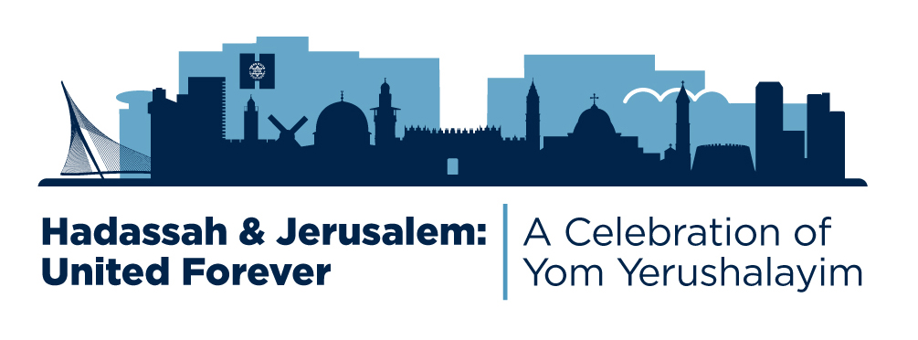

**Hadassah & Jerusalem: United Forever:** Hadassah is presenting a festive virtual event celebrating Yom Yerushalayim on Monday, May 10, at 7:30 pm ET. It features musical performances from Jerusalem and will be hosted by Broadway actress Tovah Feldshuh. Hadassah and Jerusalem are inextricably intertwined and have been for more than 100 years. Join the celebration and bring a taste of Israel into your home. [Register today for your complimentary tickets here](https://hadassah.org/events/YomYerushalayim).