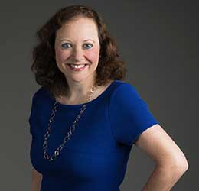President’s Message, October 2021

An unknown philosopher wrote, “Autumn is the season that teaches us that change can be beautiful.” Nature explodes with color and the cooling winds are a welcome contrast to the heat of summer. In keeping with the theme that there is beauty in change, Hadassah is thrilled to name a new CEO, [Naomi Adler.](https://www.hadassah.org/press-release/naomi-adler-named-ceo-of-hadassah) Naomi comes to Hadassah with decades of executive nonprofit and Jewish communal experience. National President Rhoda Smolow stated, “We are thrilled to welcome Naomi Adler as Hadassah’s new CEO. A proven nonprofit leader with deep expertise in Jewish communal work and an impressive track record of community engagement, fundraising and advocacy, she is the ideal person to build on Hadassah’s past achievements, increase its global impact and take Hadassah into the next phase of its growth.” Naomi, who began her career as an assistant district attorney with a reputation for protecting the rights of women and children, will have the opportunity to bring a new vision to the job of CEO. We welcome her.

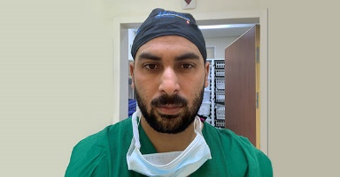**HMO Update**: Change allows for innovation and opportunity. To that end, Hadassah celebrates the graduation of its very first PhD candidate in nursing, [Mahmoud Khateb,](https://www.hadassah.org/story/hadassah-celebrates-first-phd-graduate-in-nursing) age 33. The opportunity was made possible due to the generosity of Patricia Lapan Hadassah-Hebrew University School of Nursing Scholarship Program. “The Lapan gift enables us to continue with our studies with much less financial worry,” says Khateb. “The members of the Lapan family are part of our success. They have allowed us to delve deeper, to use better statisticians. We couldn’t do this without that financial backup.” Khateb was among the first five students accepted to the newly opened program in 2016 and the first to complete his research and dissertation. He investigated an issue in the field of bariatric surgery looking at how the surgery affects a woman’s self-image, mental state and sexual functioning. Hadassah continues to make innovations in curriculum to meet the changing needs of Israel’s population.

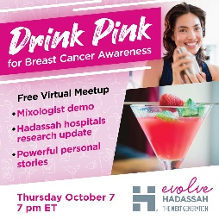**Membership Update**: While many things change, the core of Hadassah’s values have remained the same since Henrietta Szold founded Hadassah in 1912: Supprting practical Zionism and inspiring women to action. To engage each successive generation, Hadassah proudly announces a new tagline for the Young Women’s Department: [Evolve Hadassah](https://www.hadassah.org/get-involved/evolve-young-women): The Next Generation. It’s kicking off what will be an Evolve signature annual event: a “Drink Pink” online meetup for breast cancer awareness on **October 7 at 7 pm**. There will be a live national program, and young women’s groups across the country are encouraged to make it a part of their own local watch parties and programs. A mixologist will demonstrate pink beverages, and Dr. Shani Paruch-Shimon, director of Breast Oncology at Hadassah, will offer a medical research update on breast cancer. [The event](https://secure2.convio.net/wzoa/site/Ticketing?view=Tickets&id=105243&fbclid=IwAR0AAFXVPWQS2olUbw10W-YeSVZq5Ccx3ao4TrL2QmpIDYSp-na94jAZ__Q) will also feature the compelling personal stories of strength from two young members.

** Philanthropy Update**: It is often said, “Be the change you want to see.” In order to support Hadassah’s ongoing dynamic medical and humanitarian work, consider becoming an annual giver or stepping up your annual pledge. [Annual givers](https://www.hadassah.org/donate/learn-more/annual-giving) can choose to give to Hadassah’s greatest needs or designate their gifts to a Hadassah project. *Keepers of the Gate* is a recurring gift program for donors who contribute $1,000 or more annually. *Chai Society* is a recurring gift program for donors who give $180 to $999 annually. We know that annual gifts are a significant, reliable source of funds to support our projects: medical breakthroughs and treatments at Hadassah Medical Organization, fostering Jewish continuity through Young Judaea, and helping disadvantaged children through Youth Aliyah. In today’s changing world, Hadassah continues to reassess and refocus our commitment to women’s equality, Israel and Jewish values, and the health and well-being of all people.